

Project Name: “EventHub”

Branch PG-DAC March-2024

Documentation On

**“EventHub”**

PG-DAC March 2024

**Guided By: Snehal Somvanshi**

Submitted By:

**Group No: 20**

* **Harshal Khushal Patil 240343020040**
* **Prasad Shivaji Patil 240343020071**
* **Pratap Mukund Bhosale 240343020072**
* **Akash Santosh Salvi 240343020087**

**Table of Contents**

1. **Introduction** .............................................................................................................. 1  
   1.1 **Document Purpose** ............................................................................................. 1  
   1.2 **Project Background** ............................................................................................. 1  
   1.3 **Aim & Objective** .................................................................................................. 1  
   1.4 **Organizer and Attendees** .................................................................................... 1
2. **Business Requirements Overview** ............................................................................ 2
3. **Functional Requirements Overview** ......................................................................... 2  
   3.1 **Admin Module** ................................................................................................... 2  
   3.2 **Organizer Module** .............................................................................................. 2  
   3.3 **Attendee Module** ............................................................................................... 2
4. **Non-Functional Requirements** ................................................................................. 3
5. **Use Case Diagram** ..................................................................................................... 4
6. **Database Design** ....................................................................................................... 7
7. **Snapshots** ................................................................................................................ 10
8. **ER Diagram** …………………………………………………………………………………………………………. 16
9. **Conclusion** ................................................................................................................ 16

# 1. Introduction

## **1.1 Document Purpose**

## This document outlines the business requirements and scope for developing the EventHub web application, which is designed to manage and organize events, while providing attendees with the ability to book and manage their participation. The purpose of this document is to define the necessary features, functionalities, and constraints to create a successful, user-friendly event management system. The scope includes defining both functional and non-functional requirements, business rules, and other relevant constraints.

## **1.2 Project Background**

## The demand for efficient event management systems has grown significantly, particularly with the increase in both virtual and in-person events. Organizers require streamlined platforms to manage events, while attendees seek convenient methods to discover, book, and participate in these events. EventHub aims to address this demand by offering a comprehensive, user-centric platform that facilitates event creation, management, and attendee interaction in a seamless manner.

## **1.3 Aim & Objective**

## The aim is to develop a user-friendly, web-based EventHub application that simplifies event organization and enhances the attendee experience through the following objectives:

## Develop an intuitive and responsive web application.

## Enable event organizers to create and manage events efficiently.

## Allow attendees to easily search for, book, and manage their event participation.

## Implement secure payment processing for ticket sales.

## Provide real-time updates and notifications to both organizers and attendees.

## Facilitate communication between organizers and attendees.

## Offer a feedback system to improve event quality and user satisfaction.

## Analyze user data to enhance features and functionalities.

## **1.4 Organizer and Attendees**

**Organizer:**

* Event organizers of all sizes, including businesses, non-profits, and individuals.
* Attendees seeking to participate in a variety of events, from conferences to concerts.
* Companies looking to host or sponsor events.

**Attendees:**

* Event management professionals (event planners, coordinators).
* Businesses and organizations in need of a reliable event platform.
* Technology companies specializing in web development and event solutions.
* Investors interested in the event management sector.

# 2. Business Requirements Overview

* **Target Platform:** The EventHub application will be developed as a web-based platform accessible through all modern web browsers, ensuring broad accessibility for both event organizers and attendees.
* **User Interface:** The application will feature a user-friendly, intuitive, and visually appealing interface that caters to both organizers and attendees. The design will focus on ease of navigation, quick access to key functionalities, and a seamless user experience across different devices.
* **Monetization Strategy:** EventHub will adopt a freemium model, where the basic event management and booking functionalities are available for free. Premium features, such as advanced event analytics, priority support, and enhanced customization options, will be offered through subscription plans or one-time purchases.

# 3. Functional Requirements Overview

## 1. Admin Module

## 2. Organizer Module

## 3. Attendee Module

**3.1 Admin Module:**

* Admin Approve or Reject the request of Organizer
* Admin can view the Events, Create Category, Create Venue
* All transactions and Feedback are visible to the Admin.

**3.2 Organizer Module:**

* First time user have to register first, once the user is approved by the admin then he can login to his account.
* Logined user see the options add event, view and update event details, cancel booking, view feedback.
* In add event user can select the category of the event, while adding event user should provide a short description about the event.
* Organizer having option to provide no of seats. He can view booking, cancel events.
* Organizer can view the feedback given by the attendee.

**3.3 Attendee Module:**

* Attendee access organized event and book the tickets to attend the events.
* Attendee can book the multiple the tickets after that forwarded to the payment page and once the payment get successful he get the message.
* Attendee can give the feedback about the event.

# 4.Non-Functional Requirement

* **Performance:** The EventHub application should be responsive and efficient, ensuring that users can interact with the platform seamlessly. It should handle large volumes of event data, user interactions, and ticket transactions without experiencing lag or crashes.
* **Scalability:** The application should be designed to scale, allowing it to accommodate future growth in the user base, event listings, and additional features. This ensures that the platform can expand and evolve without compromising performance.
* **Social Integration:** EventHub should provide features that allow users to connect with friends, colleagues, or fellow event-goers. Users should be able to share events, invite others, and participate in virtual event communities, enhancing the social experience around event participation.
* **Offline Functionality:** The application should allow users to view upcoming events even when they are offline. This ensures that users can access crucial event details regardless of their internet connectivity status.

# 5.Use Case Diagram

1. **Admin:**

**Admin:**

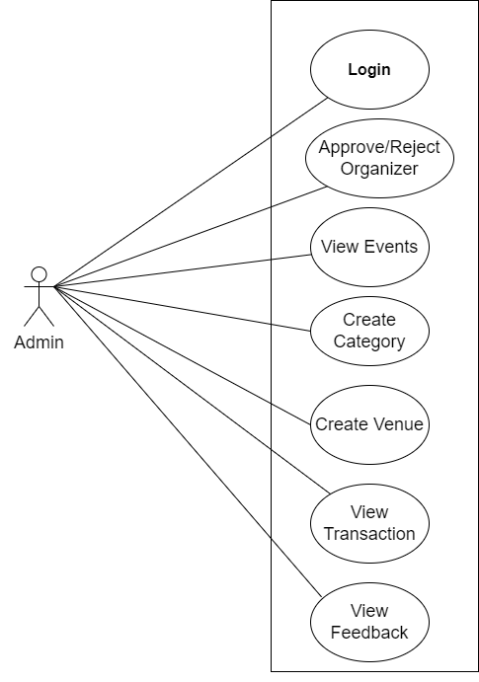

* 1. In Admin use diagram Admin is the Owner
  2. Admin can handle the following use cases:
     1. Login
     2. Approve/Reject Organizer
     3. View Events
     4. Create Category
     5. Create Venue
     6. View Transactions
     7. View Feedback

1. **Organiser:**

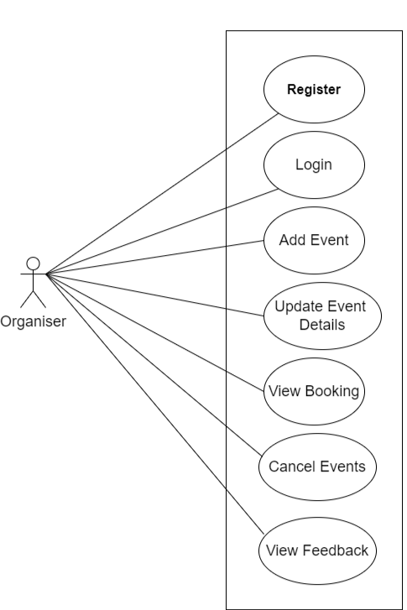

**Organizer**:

* + 1. In Organizer use case diagram Organizer is the User.
    2. Customer can handle following use cases:
       1. Register
       2. Login
       3. Add Event
       4. Update Event details
       5. View Booking
       6. Cancel Events
       7. View Feedback

1. **Attendee:**

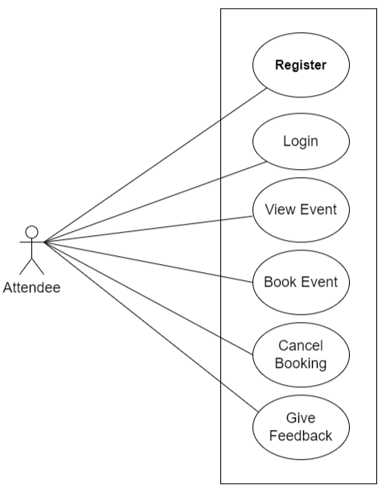

**Attendee:**

1. In Attendee use case diagram Trainer is the User

2. Attendee can handle following use cases:

* + - * 1. Register
        2. Login
        3. View Event
        4. Book Event
        5. Cancel Booking
        6. Give Feedback

# 6.Database Design

1. **Roles Table**

|  |  |  |  |  |  |
| --- | --- | --- | --- | --- | --- |
|  |  | **Roles** | |  |  |
| **Field** | **Type** | **Null** | **Key** | **Default** | **Extra** |
| role-id | INT | No | PK |  |  |
| role-name | VARCHAR (45) | No |  |  |  |

1. **Users Table**

|  |  |  |  |  |  |
| --- | --- | --- | --- | --- | --- |
|  |  | | **Users** |  |  |
| **Field** | **Type** | **Null** | **Key** | **Default** | **Extra** |
| user_id | INT | No | PK |  | AUTO_INCREMENT |
| user_name | VARCHAR (255) | No |  |  |  |
| password | VARCHAR (255) | No |  |  |  |
| fname | VARCHAR (255) | Yes |  | NULL |  |
| lname | VARCHAR (255) | Yes |  | NULL |  |
| dob | DATE | Yes |  | NULL |  |
| aadhar_no | VARCHAR (255) | No |  |  |  |
| email | VARCHAR (255) | No |  |  |  |
| pincode | VARCHAR (255) | No |  | NULL |  |
| address | VARCHAR (255) | Yes |  | NULL |  |
| mobile_no | VARCHAR (255) | Yes |  |  |  |
| rid | INT | No |  |  |  |

1. **Categories Table**

|  |  |  |  |  |  |
| --- | --- | --- | --- | --- | --- |
| **Categories** | | | | | |
| **Field** | **Type** | **Null** | **Key** | **Default** | **Extra** |
| cat_id | INT | No | PK |  | AUTO_INCREMENT |
| cat_name | VARCHAR (255) | Yes |  | NULL |  |

1. **Event Table**

|  |  |  |  |  |  |
| --- | --- | --- | --- | --- | --- |
| **Events** | | | | | |
| **Fields** | **Type** | **Null** | **Key** | **Default** | **Extra** |
| event_id | INT | No | PK |  | Auto-  Increment |
| event_name | VARCHAR (255) | Yes |  | NULL |  |
| description | VARCHAR (255) | Yes |  | NULL |  |
| date | VARCHAR (255) | Yes |  | NULL |  |
| price | DOUBLE | Yes |  | NULL |  |
| address | VARCHAR (255) | Yes |  | NULL |  |
| city | VARCHAR (255) | Yes |  | NULL |  |
| pincode | INT | Yes |  | NULL |  |
| no_of_seats | INT | Yes |  | NULL |  |
| catid | INT | Yes | FK | NULL |  |

1. **Booking Table**

|  |  |  |  |  |  |
| --- | --- | --- | --- | --- | --- |
| **Booking** | | | | | |
| **Field** | **Type** | **Null** | **Key** | **Default** | **Extra** |
| booking_id | INT | No | PK |  | Auto-Increment |
| booking_date | DATETIME | No |  |  |  |
| no_of_seats | INT | Yes |  | NULL |  |
| price | DECIMAL (10,2) | Yes |  | NULL |  |
| total_cost | DECIMAL (10,2) | Yes |  | NULL |  |
| user_id | INT | No | FK |  |  |
| event_id | INT | No | FK |  |  |

1. **Payments Table**

|  |  |  |  |  |  |
| --- | --- | --- | --- | --- | --- |
|  | | **Payments** | | |  |
| **Field** | **Type** | **Null** | **Key** | **Default** | **Extra** |
| payment_id | INT | No | PK |  | AUTO_INCREMENT |
| payment_date | DATETIME | No |  | NULL |  |
| amount | DECIMAL (10,2) | Yes |  | NULL |  |
| payment_mode | VARCHAR (45) | Yes |  | NULL |  |
| transaction_id | DECIMAL (10,2) | Yes |  | NULL | UNIQUE |
| status | VARCHAR (45) | Yes |  | NULL |  |
| booking_id | INT | Yes | FK | NULL |  |
| user_id | INT | Yes | FK | NULL |  |

1. **Feedback Table**

|  |  |  |  |  |  |
| --- | --- | --- | --- | --- | --- |
| **Feedback** | | | | | |
| **Field** | **Type** | **Null** | **Key** | **Default** | **Extra** |
| feedback_id | INT | No | PK |  | AUTO_INCREMENT |
| rating | INT | Yes |  | NULL |  |
| comment | VARCHAR (45) | Yes |  | NULL |  |
| user_id | INT | Yes | FK | NULL |  |
| event_id | INT | Yes | FK | NULL |  |

# 8.Snapshots:

**8.1 Home Page:**

Following snapshot shows the **Home Page** for EventHub application before Login.

Guest user can navigate to Registration and Login page from Home Page. He can see the upcoming events without registration too.

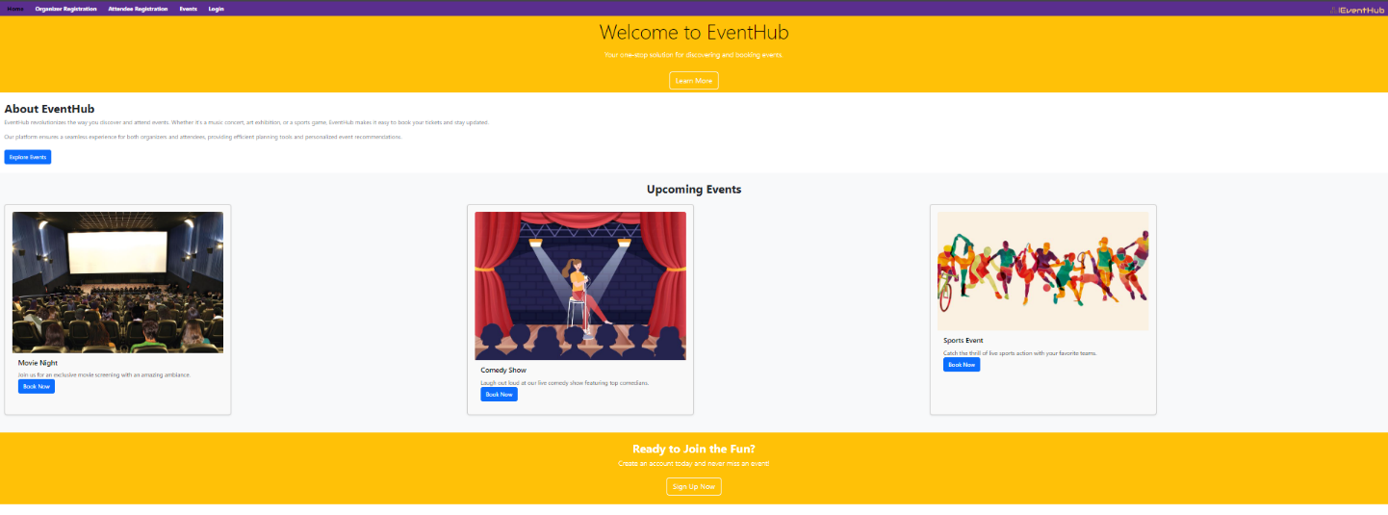

**8.2 Organizer and Attendee Registration Page:**

User can register himself as Organizer or Attendee by navigating to registration page.

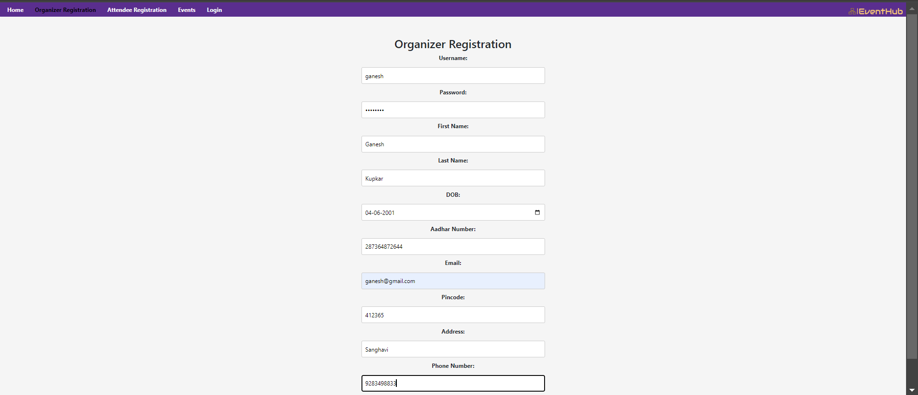

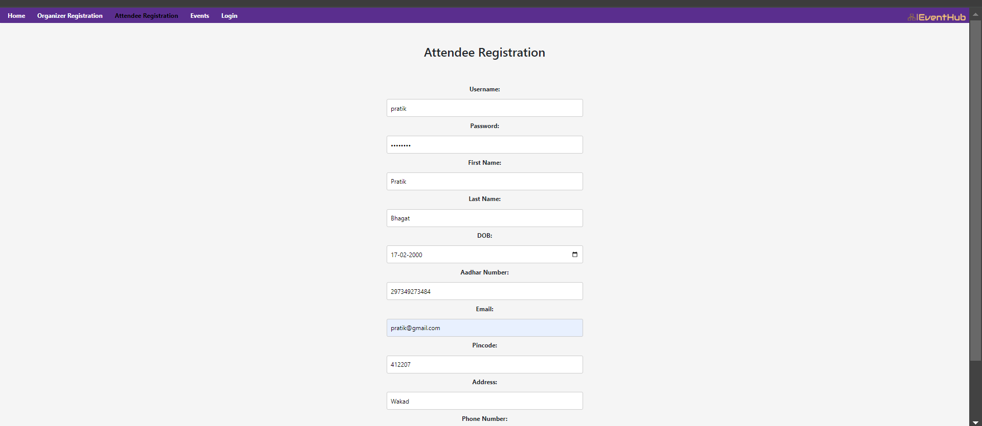

**8.3 Login Page:**

On After Registration user it is redirected to the login page user have to enter the user name and password and then click on Login button.

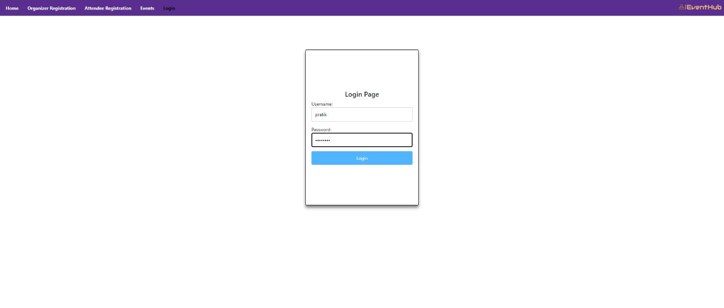

**8.4 Organizer and Attendee Home Page:**

* On Admin home page admin have the option Dashboard on which he can see Pending Events and Pending users for the approval and Logout option
* On Organizer home page organizer have the option view My Events, Bookings, Add Events and Logout option
* On Attendee home page attendee have the option view upcoming Events, Book events, Profile and Logout option

1. 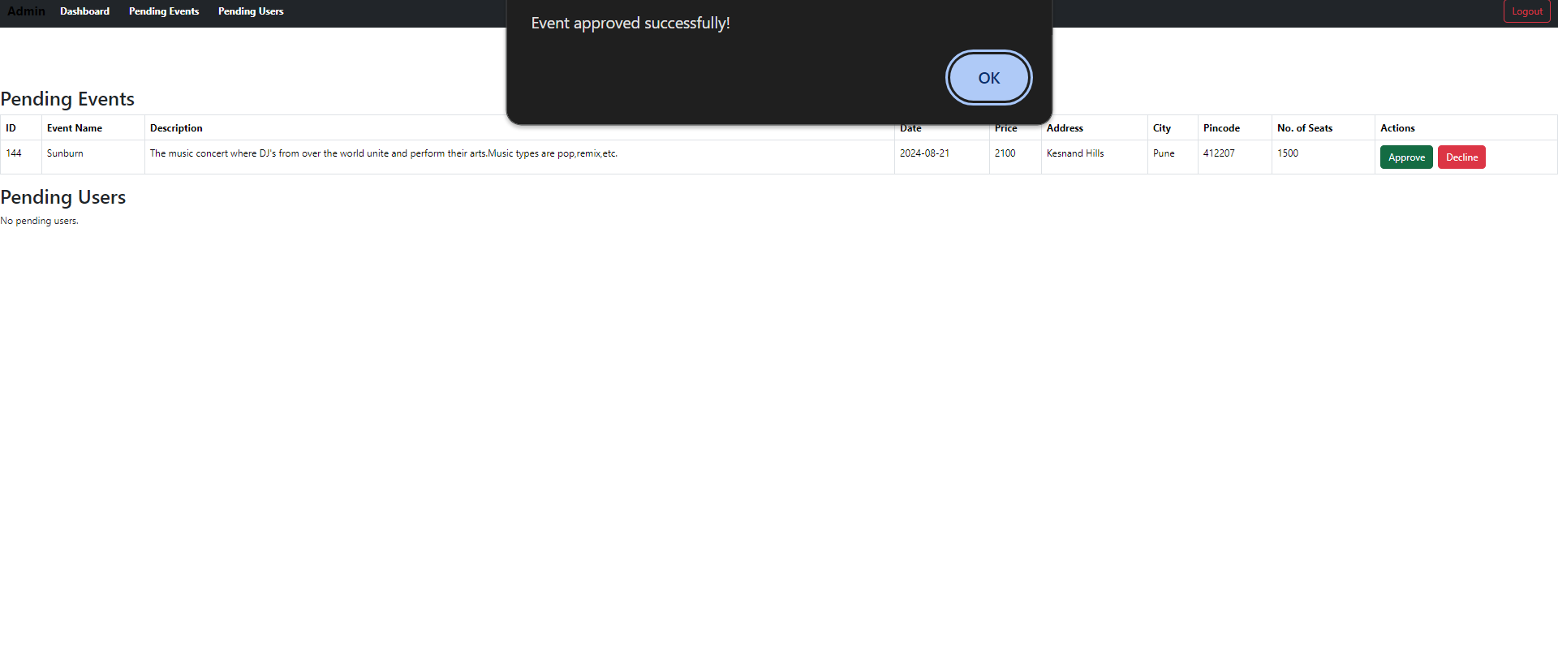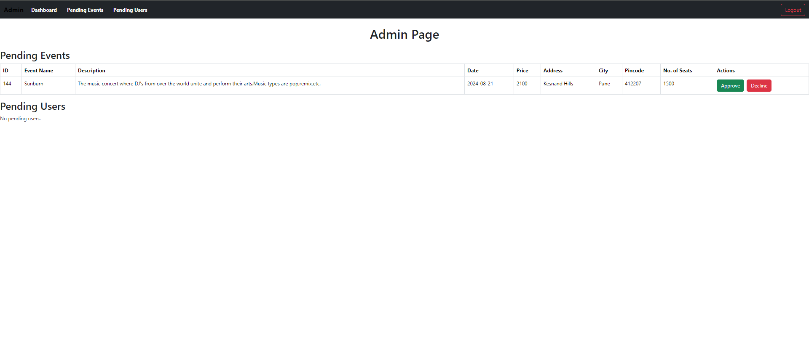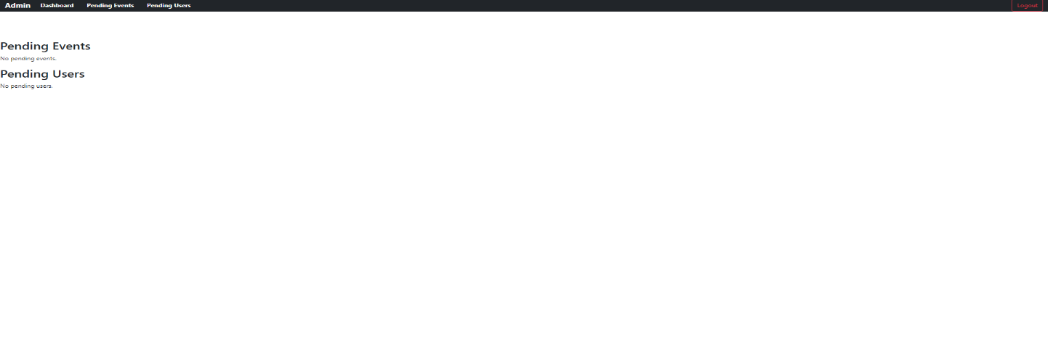**Admin Home Page:**
2. 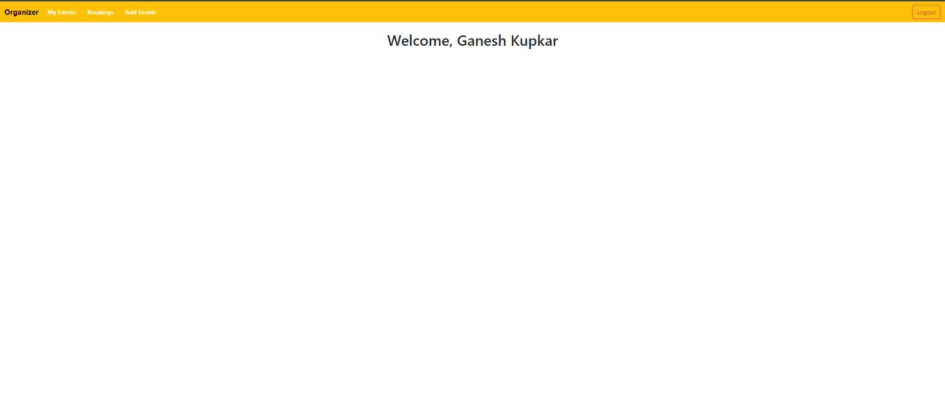**Organizer Home Page:**

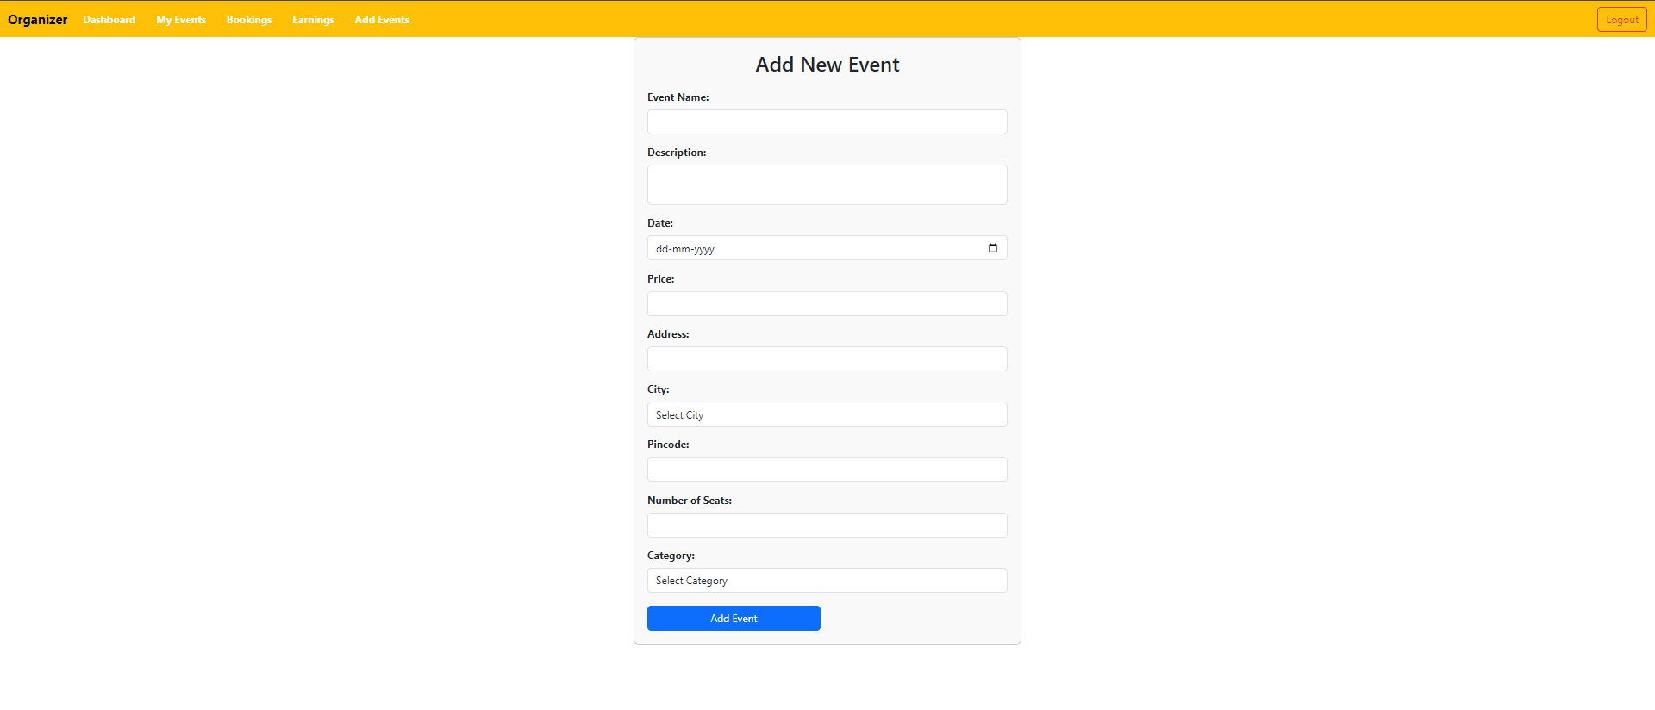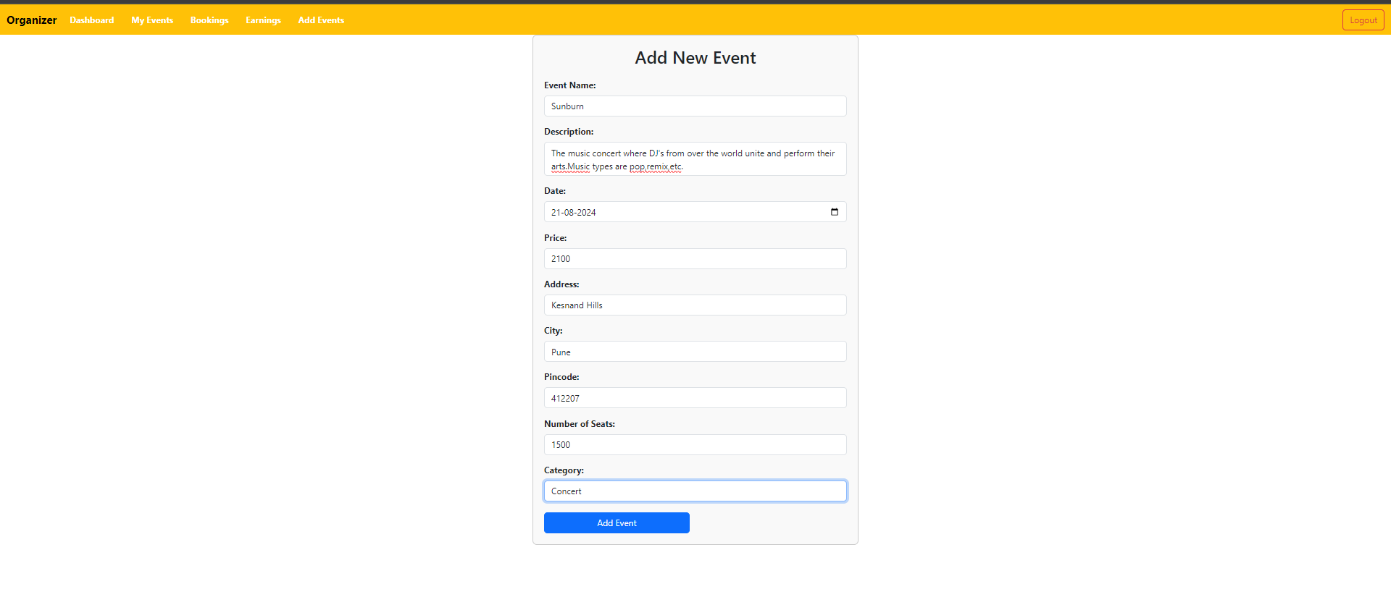

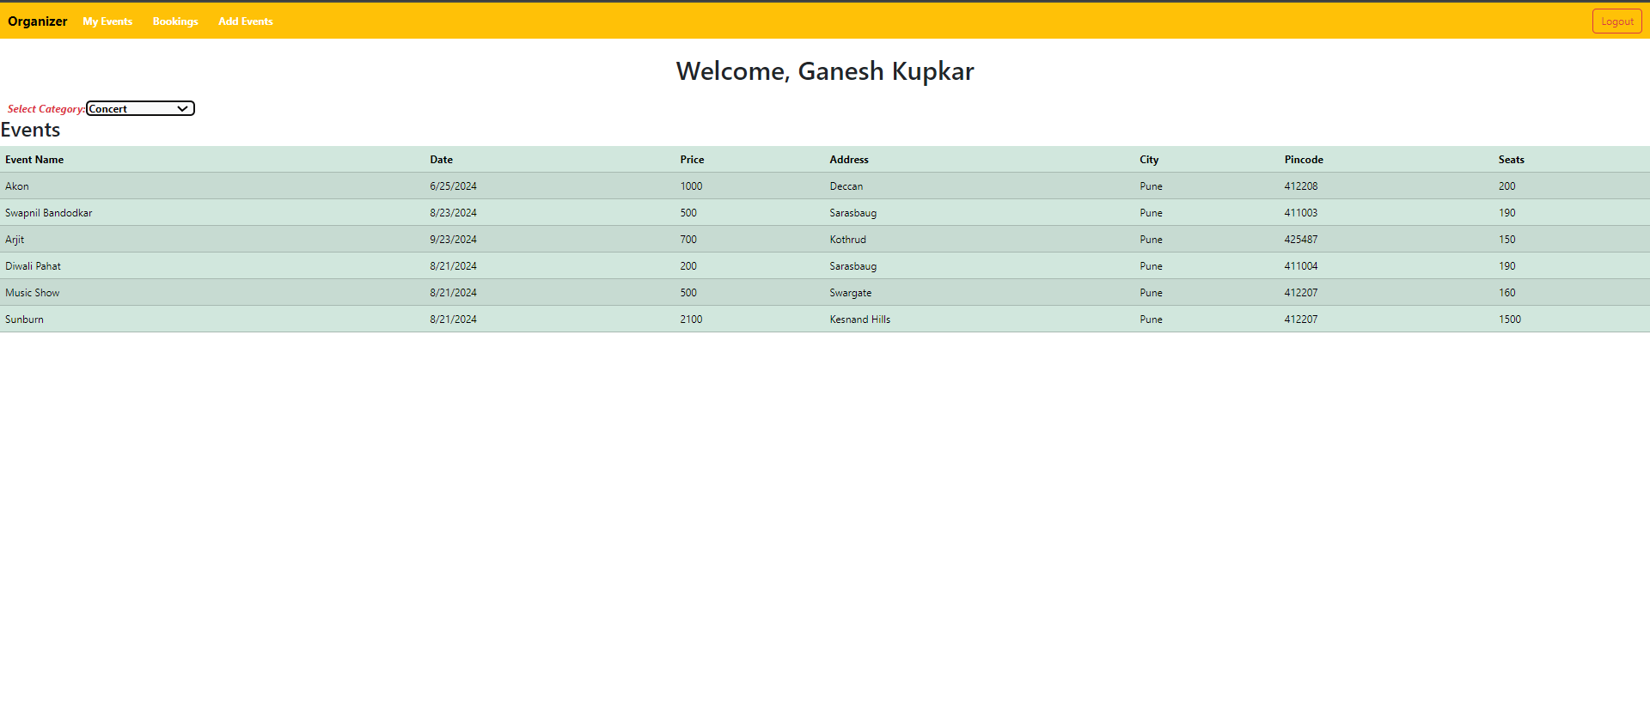

1. 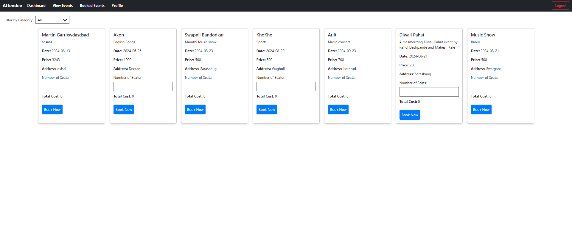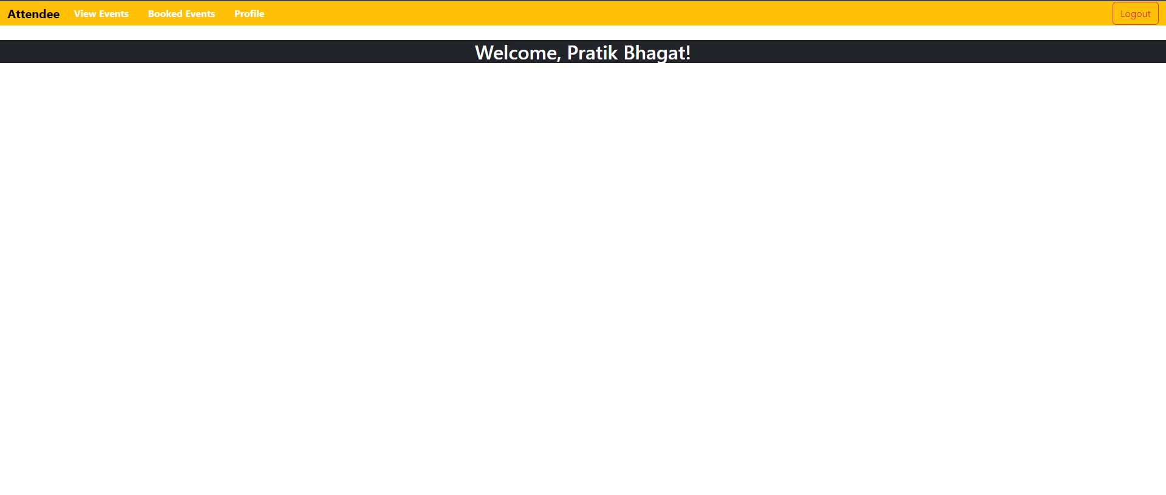**Attendee Home Page:**

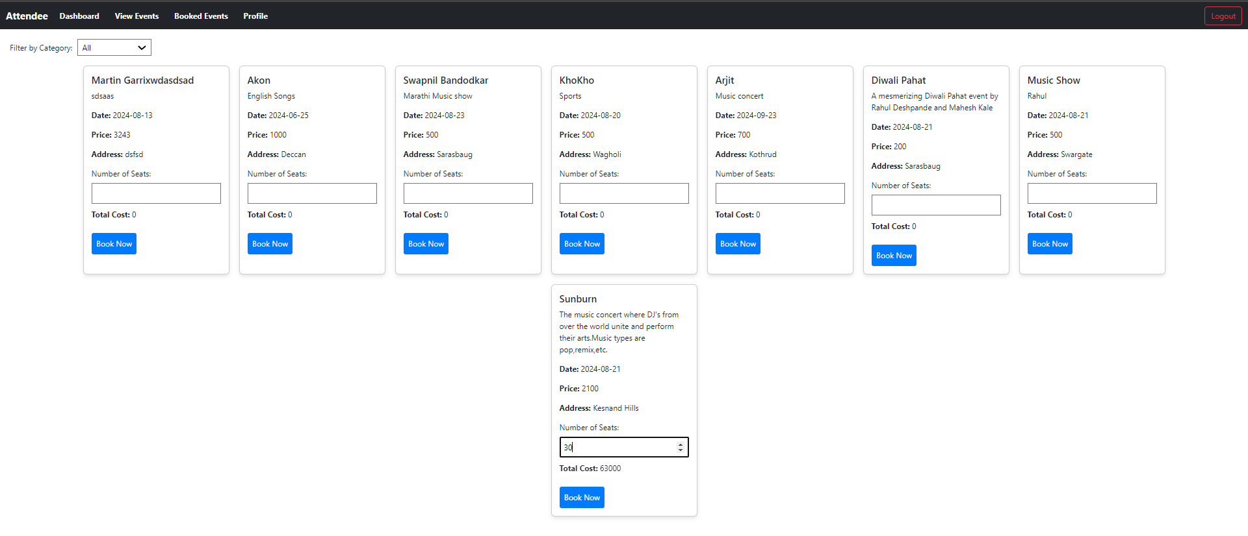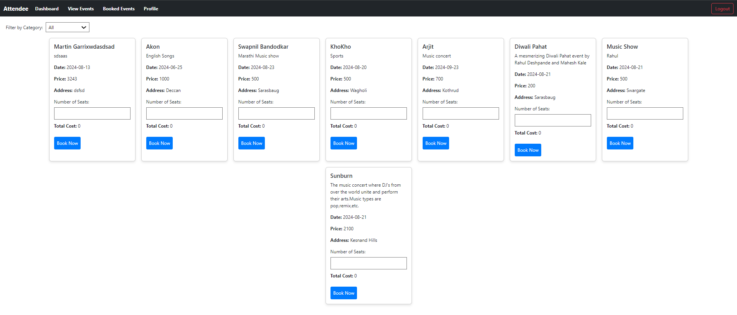

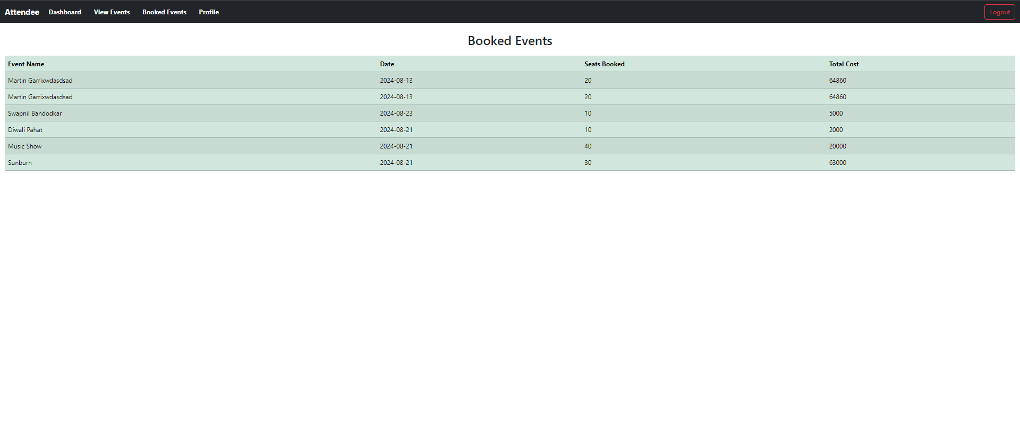

**9. ER Diagram**

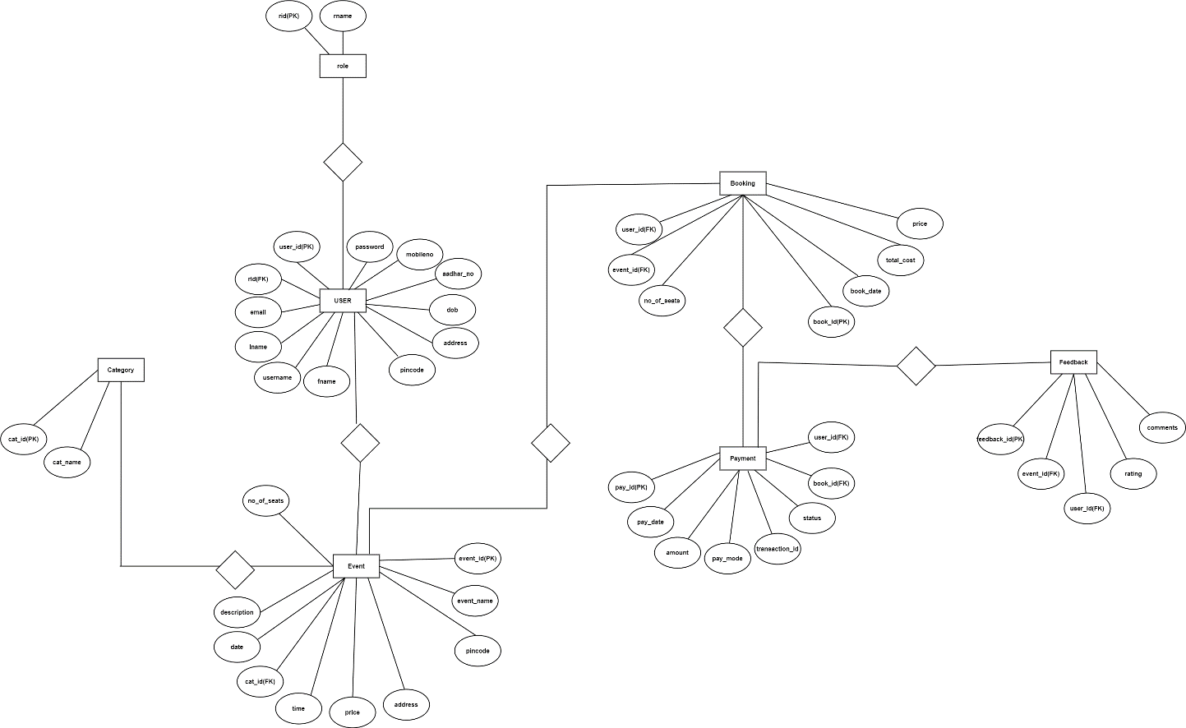

# Conclusion

The EventHub project was an invaluable learning experience that deepened our understanding of managing a complex system. Through this project, we navigated the intricacies of various functionalities like user sign-ups, event management, ticket sales, and notifications, akin to assembling the pieces of a large puzzle. The challenges we faced, including unexpected bugs and issues, taught us the importance of resilience and problem-solving as we discovered solutions and grew stronger as a team.

Additionally, our collaborative efforts were greatly enhanced by tools like Git and GitHub, which facilitated smooth teamwork and version control. The experience underscored the significance of breaking down complex tasks into manageable components, being attentive to user feedback, and maintaining effective collaboration.

Overall, this project has equipped us with practical skills and insights that will undoubtedly be beneficial in future endeavors, both in terms of technical proficiency and team dynamics.